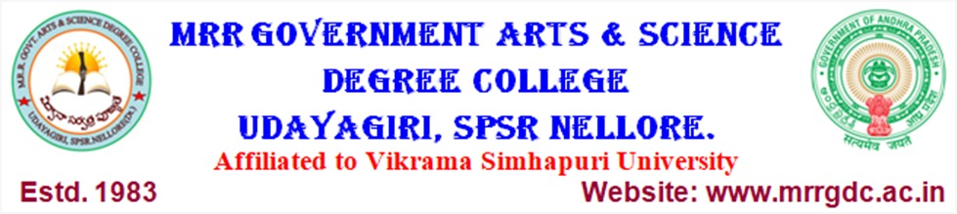

DEPARTMENT OF COMPUTER SCIENCE

RESULT ANALYSIS

Academic year | Group | No. Of student  appeared | No. Of students  Passed | Percentage
2018-2019 | SEMESTER – V | 26 | 24 | 92%
2018-2019 | SEMESTER – V | 26 | 23 | 88%
2018-2019 | SEMESTER – VI | 26 | 22 | 85%
2019 - 2020 | SEMESTER – I | 26 | 26 | 100%
2019 - 2020 | SEMESTER – II | 25 | 23 | 92%
2019 - 2020 | SEMESTER – III | 22 | 18 | 82%
2019 - 2020 | SEMESTER – IV | 20 | 16 | 80%
2019 - 2020 | SEMESTER – V | 20 | 15 | 75%
2019 - 2020 | SEMESTER – V | 20 | 19 | 95%
2020 - 2021 | SEMESTER – I | 30 | 22 | 73%
2020 - 2021 | SEMESTER – II | 30 | 19 | 63%
2020 - 2021 | SEMESTER – III | 26 | 25 | 96%
2020 - 2021 | SEMESTER – IV | 30 | 22 | 73%
2020 - 2021 | SEMESTER – V | 25 | 21 | 84%
2021-2022 | SEMESTER – III | 27 | 22 | 81%
2021-2022 | SEMESTER – IV P-1 | 27 | 17 | 63%
2021-2022 | SEMESTER – IV P-2 | 27 | 22 | 81%
2021-2022 | SEMESTER – V | 30 | 24 | 80%
2021-2022 | SEMESTER – VI | 30 | 29 | 97%
2023-2024 | SEMESTER – I | 17 | 17 | 100%
2023-2024 | SEMESTER – II | 18 | 11 | 61%
2023-2024 | SEMESTER – III | 18 | 17 | 94%

